Name | Description | example
Competition | A relationship where only one organisms benefits and the other is neither benefited or harmed. | 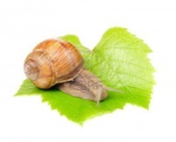  Snails eat the green leaves of plants.
Predation | Two organisms live closely together but only one benefits from the relationship. The other suffers but does not often die. It is not in the parasites interests for the host, its food source, to die. | 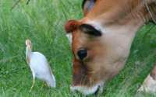The cattle egret eats the insects hiding under vegetation close to the ground. The insects are stirred up when the cattle walk through them.
Mutualism | Organisms compete for the same resources, eg: space, food, water nesting sites. | 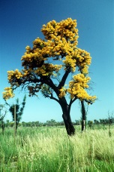  The WA Christmas tree gains water in a dry environment by tapping into the roots of other trees.
Parasitism | One organism eats either whole or part of another for food | Bees feed on the nectar found in flowers. While they are feeding some pollen collects on their bodies. When they visit the next flower they pollinate the flower.
Commensalism | Two organisms live closely together and both benefit from the relationship. | There is one pond containing beetles which both frogs and green snakes require as a food source.
How Organisms Affect Each Other
The names, descriptions and examples of organisms affecting each other are mixed up.
Cut out each of the boxes below and glue them in the correct order in your notes.

